TRUSSES:
The basic building block of a truss is a triangle. Large truss are constructed by attaching several triangles together. A new triangle can be added truss by adding two members and a joint. A truss constructed in this fashion is known as a simple truss. A truss is analyzed by using m = 2j – 3, where m is number of members, j represents the number of joints and 3 represents the external support reactions.
Plane truss lie in a single plane.
In straight members forces act along the axis of the member. Compressive forces tend to shorten the member. Tensile forces tend to elongate the member.
Space trusses: not contained in a single plane and/or loaded out of the structure plane.
There are four main assumptions made in the analysis of truss
1. Truss members are connected together at their ends only.
2. Truss are connected together by friction less pins.
3. The truss structures is loaded only at the joints
4. The weights of the members may be neglected.
Techniques for Truss Analysis
Method of joints: usually used to determine forces for all members of truss
Method of sections: usually used to determine forces for specific members of truss
Determining Zero-force members: members which do not contribute to the stability of a structure
Determining conditions for analysis: is the system statically determinate?

PART – 2
ANIMATION STEPS
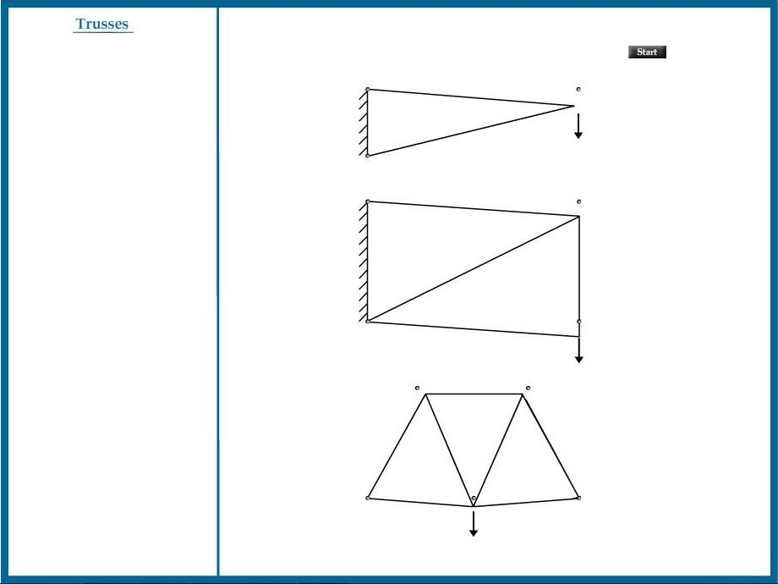

PART – 3
VIRTUAL LAB FRAME

